Arduino Lab 3

|  |  |  |
| --- | --- | --- |
| Name | Abdelrahman Wael Abohashem | Ahmed Hesham Ahmed |
| ID | 20010869 | 20010234 |

Components Used:

* 50 KΩpotentiometer
* Buzzer
* Arduino
* bread

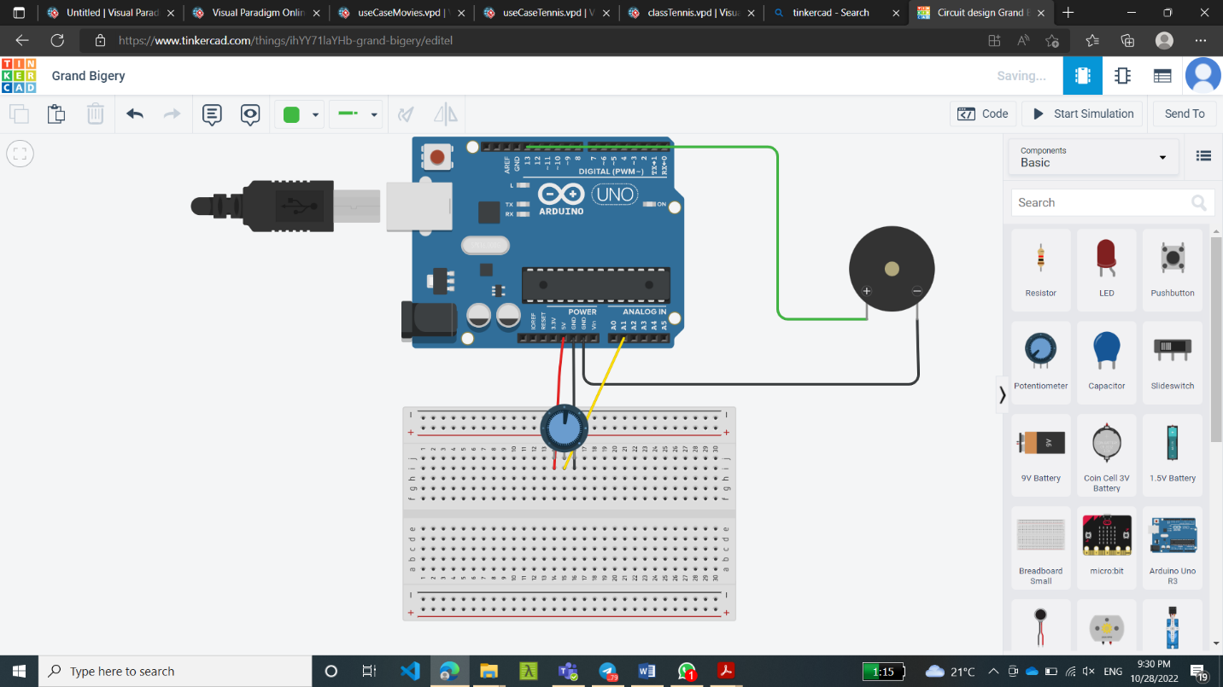Connections:

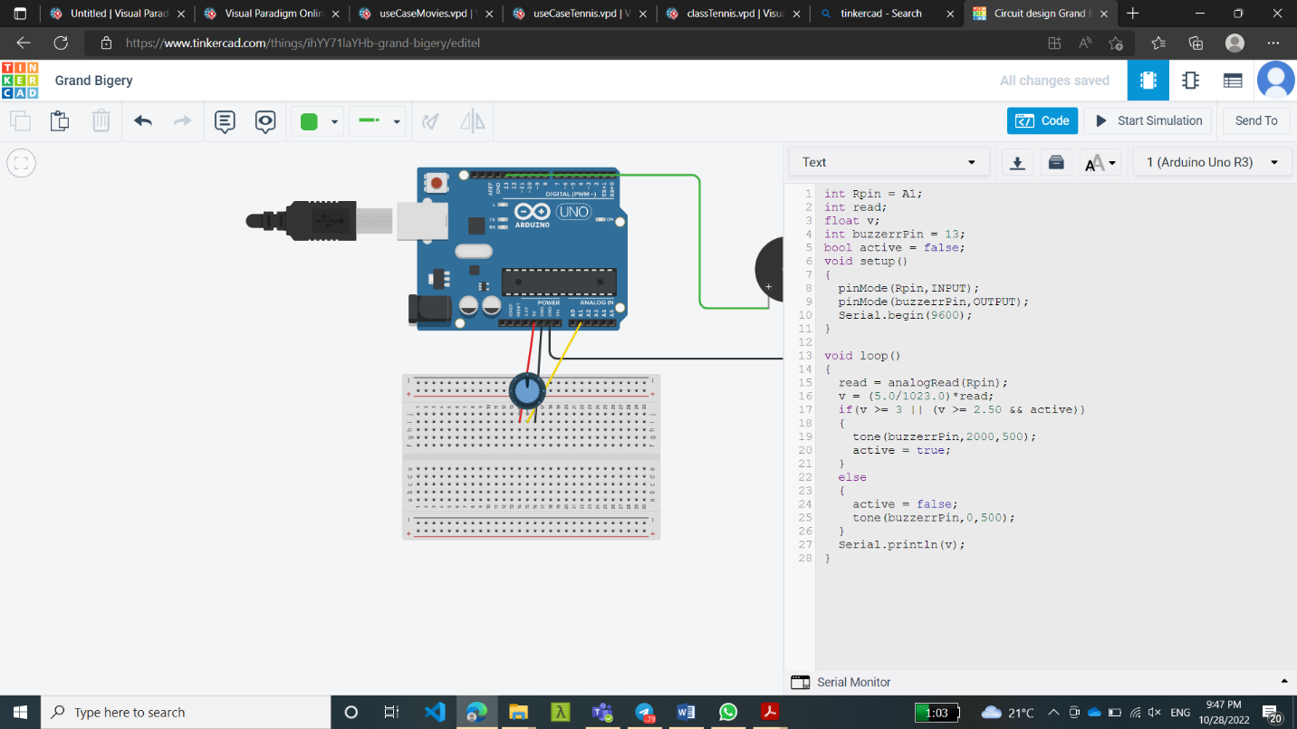Code:

Code explanation:

At voltage = 5v, the analog bin reads 1023 so to read the actual voltage multiply analog reading by 5/1023

Video Link:

https://drive.google.com/file/d/1DC1tkOuFrvfQteuJWLbnxiDXPVZKLKEY/view?usp=share_link